Below table shows the overall statistics for the local government area. A budget of $24649,428.00is divided among 15 schools. 72.81% of the students have passed both Maths and Reading subjects.



The top 5 schools with the highest overall passing percentage are Griffin High School, Cabrera High School, Bailey High School, Wright High School, Rodriquez High School, respectively.

The bottom 5 schools with the highest overall passing percentage are Hernandez High School, Huang High School, Johnson High School, Wilson High School, Ford High School, respectively.

Bailey High School and Rodriquez High School students are comparatively scoring higher for maths than reading through out all the year levels.

Throughout all the schools year 11 students perform better in reading while year 10s perform better in Maths.

**As the Budget per student increases, the scores ten to decrease. The best results are from the students in the spending range of $585-630.**

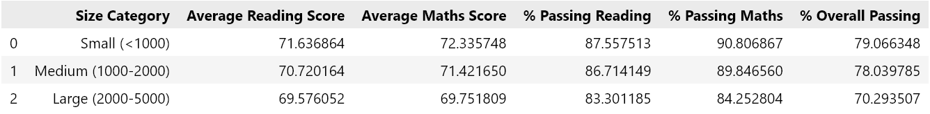

**The larger the size of the group the lesser the passing percentages are for the students indicating that smaller sized schools perform in standardised tests.**

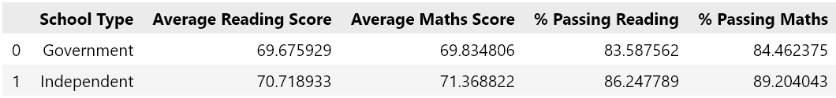

Independent schools have a higher average score and a higher passing percentage compared to government schools.